PREP2:

Patient sticker

12-week upper limb functional outcome prediction (PHASE 1, SAFE ≥ 5)

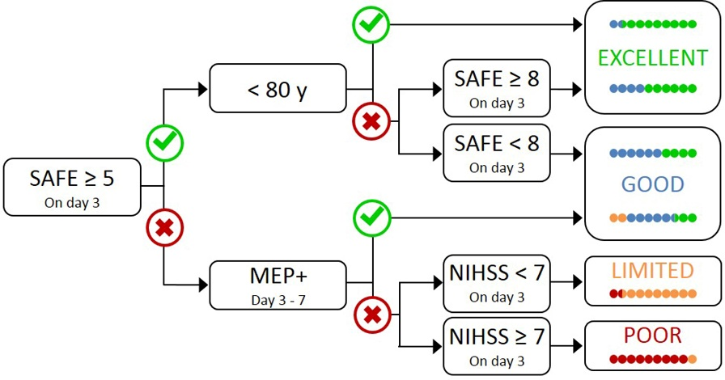

Phase 1

Added in
Phase 2

Perform NIHSS on Day 3

This algorithm can be used with patients aged 18 years or more with new upper limb weakness after stroke. This includes patients with ischaemic stroke or intracerebral haemorrhage, as well as patients treated with thrombolysis and/or endovascular thrombectomy, and includes patients who have had a previous stroke. It is not appropriate for patients admitted with a cerebellar stroke, or bilateral infarcts.

DAY 0 (Date of Stroke onset) =

SAFE DAY 1: | /10 | (Shoulder Abduction; | / 5 | Finger Extension; | / 5)
SAFE DAY 2: | /10 | (Shoulder Abduction; | / 5 | Finger Extension; | / 5)
SAFE DAY 3: | /10 | (Shoulder Abduction; | / 5 | Finger Extension; | / 5)

If a patient’s SAFE score is ≥ 5 on Day 3, a prediction can be made using the algorithm above.
Only Excellent and Good predictions can be delivered during Phase 1. Otherwise further assessment is needed to predict their upper limb functional outcome.

Based on the above information, the following prediction can be made regarding this patient’s upper limb outcome at 12 weeks:

Insert appropriate sticker here

Excellent Good

Please remember to provide written information regarding this prediction to the patient, and include a copy of this in the notes.

