PREP2 Summary for Clinical Staff

How does it help to predict upper limb motor outcomes?

Being able to predict upper limb motor outcomes for individual patients soon after stroke could help in several ways. For example, knowing the level of predicted motor recovery could help with discharge planning and realistic goal setting for clinicians and patients. It could also help with the appropriate allocation of time and resources by both the patient and the therapy team.

Clinicians often find it difficult to accurately predict functional outcomes, especially for patients with moderate to severe initial impairment. Currently, no single clinical measure or neurological biomarker is able to accurately predict motor recovery or outcome for all patients. This is why PREP2 combines measures and biomarkers to make accurate predictions for these patients.

The PREP2 algorithm

The PREP2 algorithm is a simple, sequential decision tree that combines clinical measures and neurological biomarkers in the initial days after stroke to predict upper limb functional outcomes at 3 months. It includes a Shoulder Abduction and Finger Extension (SAFE) clinical score, transcranial magnetic stimulation (TMS) to assess corticospinal tract function (by determining MEP status) and the NIHSS score. A SAFE score alone produces a prediction for almost two-thirds of patients. TMS and the NIHSS score are only used to resolve uncertainty for patients with more severe initial impairment.
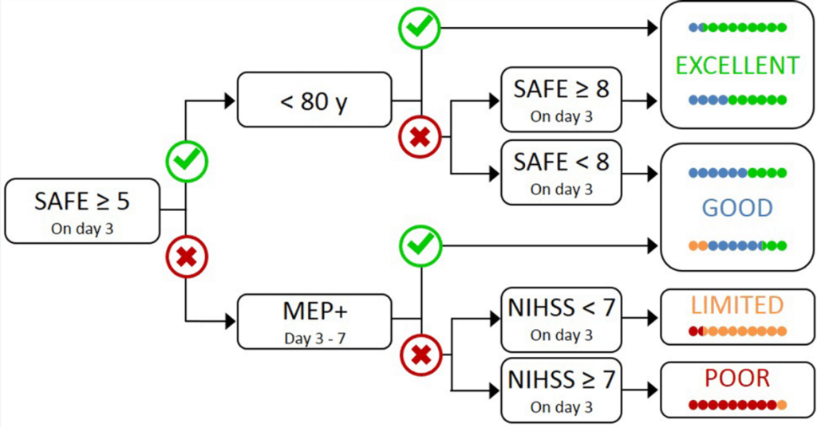

PREP2 predicts an excellent, good, limited or poor upper limb motor function outcome for individual patients.

- If a patient achieves a SAFE score of ≥ 5 within 72 hours poststroke, knowing their age allows prediction of an Excellent or Good upper limb outcome.
- If the SAFE score is < 5 at 72 hours post-stroke, the NIHSS score can be obtained at this time and a TMS assessment scheduled within the next 3 days.
- Patients in whom TMS elicits MEPs in the paretic upper limb (MEP+) are predicted to have a Good outcome.
- MEP- patients with an NIHSS score < 7 are predicted to have a Limited outcome, while MEP- patients with an NIHSS score ≥ 7 are predicted to have a Poor outcome.

Prediction information is shared with the patient, their family and clinical staff, and can be used to focus rehabilitation.

Research has shown that using PREP algorithm information increases clinician confidence, helps tailor rehabilitation and improves rehabilitation efficacy (Stinear et al., 2017).

Which patients is PREP2 used for?

PREP2 is suitable for most stroke patients. It has been developed, validated and revised with patients aged at least 18 years and new arm weakness due to either ischaemic or haemorrhagic stroke. PREP2 can be used with patients who have had thrombolysis and/or clot retrieval, as well as patients with a history of previous stroke. PREP2 may not be suitable for patients who have severe aphasia or cognitive impairment that limits their ability to understand the tests involved, or if there are contraindications to TMS. PREP2 has not been tested with patients with cerebellar stroke or bilateral stroke.

How well does PREP2 predict upper limb outcomes?

PREP2 was developed in a study including 207 stroke patients recruited within three days poststroke (Stinear et al., 2017b). Overall, PREP2 correctly predicted upper limb outcome for 156 of 207 patients (75%). Of the remaining 51 patients, the algorithm was too optimistic for 35 patients (69%) and too pessimistic for 16 patients (31%). Most of the patients for whom the algorithm was too optimistic were predicted to have an excellent outcome, but had a good (n = 25) or limited (n = 1) outcome instead. Almost all of the patients for whom the algorithm was too pessimistic were predicted to have a good outcome, but had an excellent outcome instead (n = 14).

Combining a patient’s SAFE score with their age provides a prediction for 68% of patients and discriminates with 78% accuracy between patients who have excellent or good upper limb function 3 months post-stroke. For patients with a SAFE score below 5, NIHSS score without MEP status can predict either a good or poor outcome with only 55% accuracy. The addition of TMS biomarker information increases prediction accuracy to 70% for these patients, highlighting the importance of testing corticospinal tract function in patients with more severe motor impairment.

References

Stinear CM, Byblow WD, Ackerley SJ, Barber PA, Smith MC. Predicting recovery potential for individual patients increases rehabilitation efficiency after stroke. Stroke 2017 48(4): 1011-9. DOI: 10.1161/STROKEAHA.116.015790. PMID: 28280137

Stinear CM, Byblow WD, Ackerley SJ, Smith MC, Borges VM, Barber PA. PREP2: A biomarker-based algorithm for predicting upper limb function after stroke. Ann Clin Transl Neurol 2017: 1-10. DOI: 10.1002/acn3.488

Stinear C. Prediction of motor recovery after stroke: advances in biomarkers. Lancet Neurology 2017 16(10): 826-36.

