Patient sticker
PREP2:
12-week upper limb functional outcome prediction

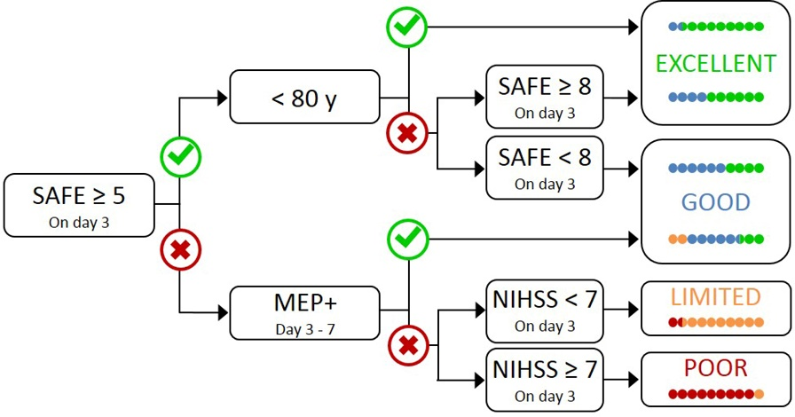

Perform NIHSS on Day 3

This algorithm can be used with patients aged 18 years or more with new upper limb weakness after stroke. This includes patients with ischaemic stroke or intracerebral haemorrhage, as well as patients treated with thrombolysis and/or endovascular thrombectomy, and includes patients who have had a previous stroke. It is not appropriate for patients admitted with a cerebellar stroke, or bilateral infarcts.

DAY 0 (Date of Stroke onset) = ________________
SAFE DAY 1: /10 (Shoulder Abduction; / 5 Finger Extension; / 5)
SAFE DAY 2: /10 (Shoulder Abduction; / 5 Finger Extension; / 5)
SAFE DAY 3: /10 (Shoulder Abduction; / 5 Finger Extension; / 5)
If a patient’s SAFE score is ≥ 5 on Day 3, a prediction can be made using the algorithm above. Otherwise further assessment is needed to predict their upper limb functional outcome.
Please use the remainder of this form to assist with this process.
Day 3 Checklist (if SAFE < 5 on Day 3):
- Get NIHSS score
- Book TMS
NIHSS
If a patient’s SAFE score is < 5 on day 3, the patient must be assessed with the NIHSS on day 3. This score will be used if the patient turns out to be MEP -, as per algorithm above.

NIHSS score: __________________ Group: (circle) <7 ≥ 7

Patient sticker

TMS
Use transcranial magnetic stimulation (TMS) to test the function of the descending motor pathways to the paretic upper limb between 3 and 7 days after stroke symptom onset.
Referral for TMS completed:
Date:
Referred to:
Referred by:
Signed:

TMS Checklist completed:
Date:
Signed:
Signed Physician:

TMS completed:
Date:
Signed:
Print name:

Once TMS assessment completed - Patient has been assessed as being: (circle)
MEP + MEP –
TMS outcome discussed with patient: □ Yes □ Planned for delivery at later date: ____________
Friends/ Whanau present during session: _______________________________________________

Psychology referral: Please consider a referral to psychology for all MEP – patients, and others if indicated, at your discretion.
□ Referral completed □ Referral not required
Based on the above information, the following prediction can be made regarding this patient’s upper limb outcome at 12 weeks:

Insert appropriate sticker here
Excellent
Good
Limited
Poor

Please remember to provide written information regarding this prediction to the patient, and include a copy of this in the notes.

